**Task 9**

**Computer Network Lab**



**Submitted to Sir Rasikh Ali  
Submitted by Muhammad Ibtisam**

**Roll #: SU92-BSSEM-F22-288  
Section: SE-5B**

**Submitted on Dec 10th, 2024**

**DEPARTMENT OF SOFTWARE ENGINEERING  
SUPERIOR UNIVERSITY, LAHORE**

**Question:**

**Subnetting:**

* Subnetting is the process of dividing a large network into smaller networks called as “subnets.” Subnets provides each group of devices have their own space to communicate, that ultimately helps network to work easily.

**Example:**

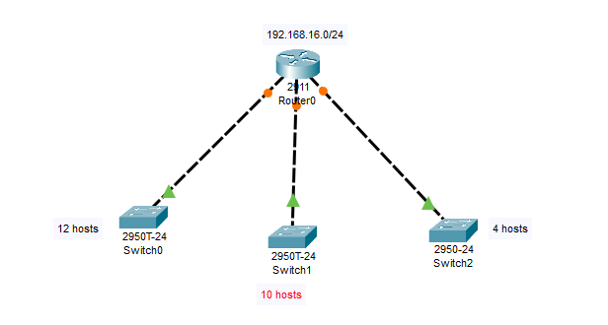

**Super netting:**

* The purpose of super netting is to reduce the size of routing tables on routers to save memory, which also shortens the amount of time IP requires to parse the routing table when determining the best path to a remote network.

**Example:**

